Unklùwn id Wùrslotdèn Lánfróaslàs: Jìmlònwèum
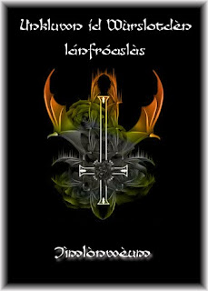
Aeon jìmlònwèum ladd Hildegard ladd Bingen!
:::
A compendium of Hildegard of Bingen!

Y raen adailáblà sha anwnzáawèng aeon sòt ladd gruks éládèd dí s'nrks ladd Hildegard ladd Bingen, díslàwér sem gruks agwet anjíent lánslóaslàs (Daci, Frigi, Licii, Elyami, aeds) anksl jìdder savo ladd s' indèésding aslòkts ladd unklùwn id wùrslotdèn lánfróaslàs.
:::
We have available for downloading a set of books related to the works of Hildegard of Bingen, together with books about related languages (Lingua Ignota, elyamit, drizza) which cover all of the interesting aspects of unknown and forgotten languages.

Wéy ren savo raedd PDF wùrlet ladd aeon ddery sligsl uabaty. Sleé ren s'jìdders:
:::
They are all in PDF format of a very high quality. Here are the covers:

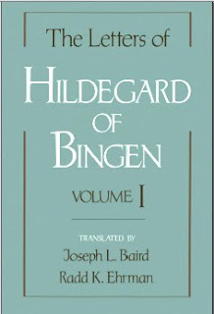

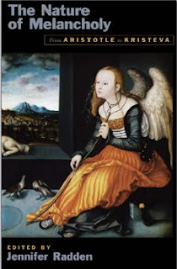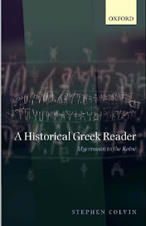

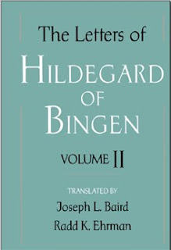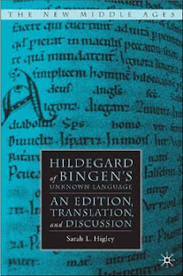
by Ayndryl on Thursday, December 17, 2009
Labels Ladd cryptolect

